Title: Describe and Find Clothing
Number of participants:2-4 per group
Learning Criteria:  - Express oneself with accuracy and fluency using the strategies studied  - Ask questions to clarify the meaning of a message | BC Core Competency:  Acquiring and presenting information- Students communicate by receiving and presenting information.
Picture of activity:  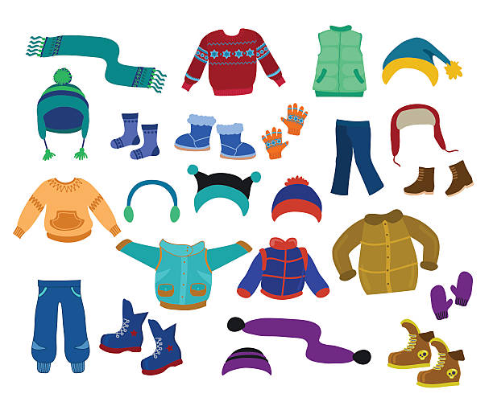 | Materials needed:  A box of clothing  - jackets, pants, socks, scarves, t-shirts, mittens, touque, ball cap, shorts, etc.  - duotang with vocab words (for those who need it)
Instructions:
Students will get into groups of 2-4 people
One student will grab a piece of clothing, while the other students face away from them
Student one will describe the piece of clothing to the other student(s)
The other student(s) will try to guess the piece of clothing that the student is describing
whoever guesses correctly gets to put that piece of clothing on
The first one to create an outfit first in the winner and becomes the person describing the clothes
To adapt it to all needs students who need the assistance can refer to their vocab pages
Other students can play the clothing dice game where they have to roll to paper dice that gives a colour and a piece of clothing and students can form a sentence or describe the full clothing in detail.

Extension/Assessment:
Students who are successful and need a higher challenge can get students to describe the clothing and have to go find the correct piece of clothing that can be located somewhere in the classroom or from a box.

References:
BC Curriculum: https://curriculum.gov.bc.ca/curriculum/francais-langue-premiere/2/core
French Winter Clothing Activity: https://www.forfrenchimmersion.com/french-winter-clothing-vocabulary/

